Status Cards Will Be Issued at the KAPAWE’NO BAND OFFICE on
STATUS CARDS

MONDAY, OCTOBER 28TH 2019
10AM – 2PM

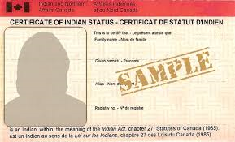
SCIS CARD applications
CIS CARDS
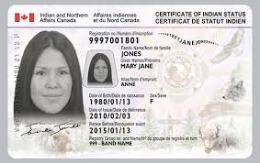
- ADULT APPLICATIONS – MUST HAVE GOVERNMENT ISSUED IDENTIFICATION
- CHILD APPLICATIONS – CHILD’S BIRTH CERTIFICATE + PARENTS IDENTIFICATION

Please call 780-751-3800
to make an appointment.

*Remember to bring I.D.
No exceptions will be made.

Michelle Colbourne, Indian Registry Administrator- LSLIRC –PH: 780-849-4943 michellec@lslirc.ab.ca

