KAPAWE’NO FIRST NATION
OIL & GAS COMPANY LTD.

Equipment List

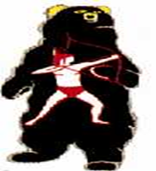

Kapawe’no First Nation Oil and Gas Company Ltd. equipment list includes but is not limited to:

KFN Equipment

- 2008 JD Backhoe with 92” front bucket and 18” rear bucket
- 2003 Hyundia LC290-7 Excavator comes with ripper, thumb, clean out and digging buckets, a ripper shank, brush rake
- 2001 740 Champion Grader c/w dozer snow wing and plow
- BC1200 Brush Chipper
- Western Star Gravel Truck
- 1990 Caterpillar DH5 LGP Crawler dozer

Contact: Interim President Chief Frank T. Halcrow

Mailing Address:
Kapawe’no First Nation Oil & Gas
P.O. Box 10
Grouard, AB
T0G 1C0

Office: 780-751-3800
Fax: 780-751-3864
Email: admin@kapaweno.ca

